SUBCOURSE EDITION
IT 0307 C

US ARMY INTELLIGENCE CENTER

PREPARE A COMSEC ACCOUNT-
DAILY SHIFT INVENTORY

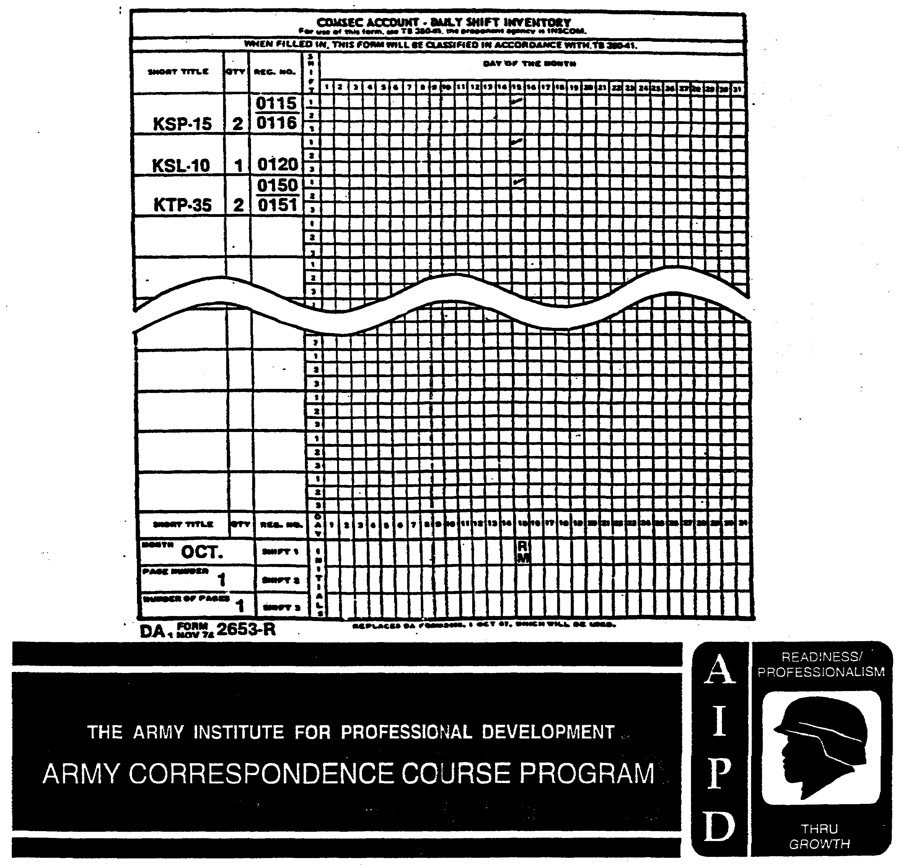

PREPARE A COMSEC ACCOUNT-DAILY SHIFT INVENTORY

Subcourse Number IT 0307

Edition C

U.S. ARMY INTELLIGENCE CENTER
FORT HUACHUCA, AZ 85613-6000

Edition Date: August 1999

2 Credit Hours

SUBCOURSE OVERVIEW

This subcourse is designed to teach you how to correctly prepare a Communication Security (COMSEC) Account-Daily Shift Inventory (DA Form 2653-R) and to inventory COMSEC material.

There are no prerequisites for this subcourse.

TERMINAL LEARNING OBJECTIVE

ACTION: You will correctly prepare a COMSEC Account-Daily Shift Inventory form (DA Form 2653-R) and to inventory COMSEC material.

CONDITION: Given the information in this subcourse.

STANDARD: To demonstrate competency of this task, you must achieve a minimum of 70% on the subcourse examination.

i IT 0307

TABLE OF CONTENTS

Section Page

Subcourse Overview i

Lesson - Prepare a COMSEC Account-Daily Shift Inventory 1-1

Practice Exercise #1 1-5
Answer Key and Feedback #1 1-7

Practice Exercise #2 1-11
Answer Key and Feedback #2 1-12

IT 0307 ii

LESSON

PREPARE A COMSEC ACCOUNT-DAILY SHIFT INVENTORY

CRITICAL TASK: 301-794-3405

OVERVIEW

LESSON DESCRIPTION:

Upon completion of this lesson, you will be able to inventory COMSEC material and prepare the COMSEC Account-Daily Shift Inventory Form.

TERMINAL LEARNING OBJECTIVE:

TASK: You will correctly prepare a COMSEC Account-Daily Shift Inventory form (DA Form 2653-R) and inventory COMSEC material.

CONDITION: Given the information in this subcourse.

STANDARD: To demonstrate competency of this task, you must achieve a minimum of 70% on the subcourse examination.

REFERENCES: The material contained in this lesson was derived from the following publications.

AR 380-40

INTRODUCTION

Inventories of COMSEC material are required for physical security, supply accountability and COMSEC material management. Shift-to-shift inventories are an important element of overall Radio Direction Finding (RDF) Security.

Your correct preparation of the COMSEC Account-Daily Shift Inventory helps you to accomplish this goal.

The COMSEC Account-Daily Shift Inventory Form, DA Form 2653-R is shown in Figure 1-1. Take a look at the form. This lesson will teach you how to prepare the inventory step by step.

1-1 IT 0307

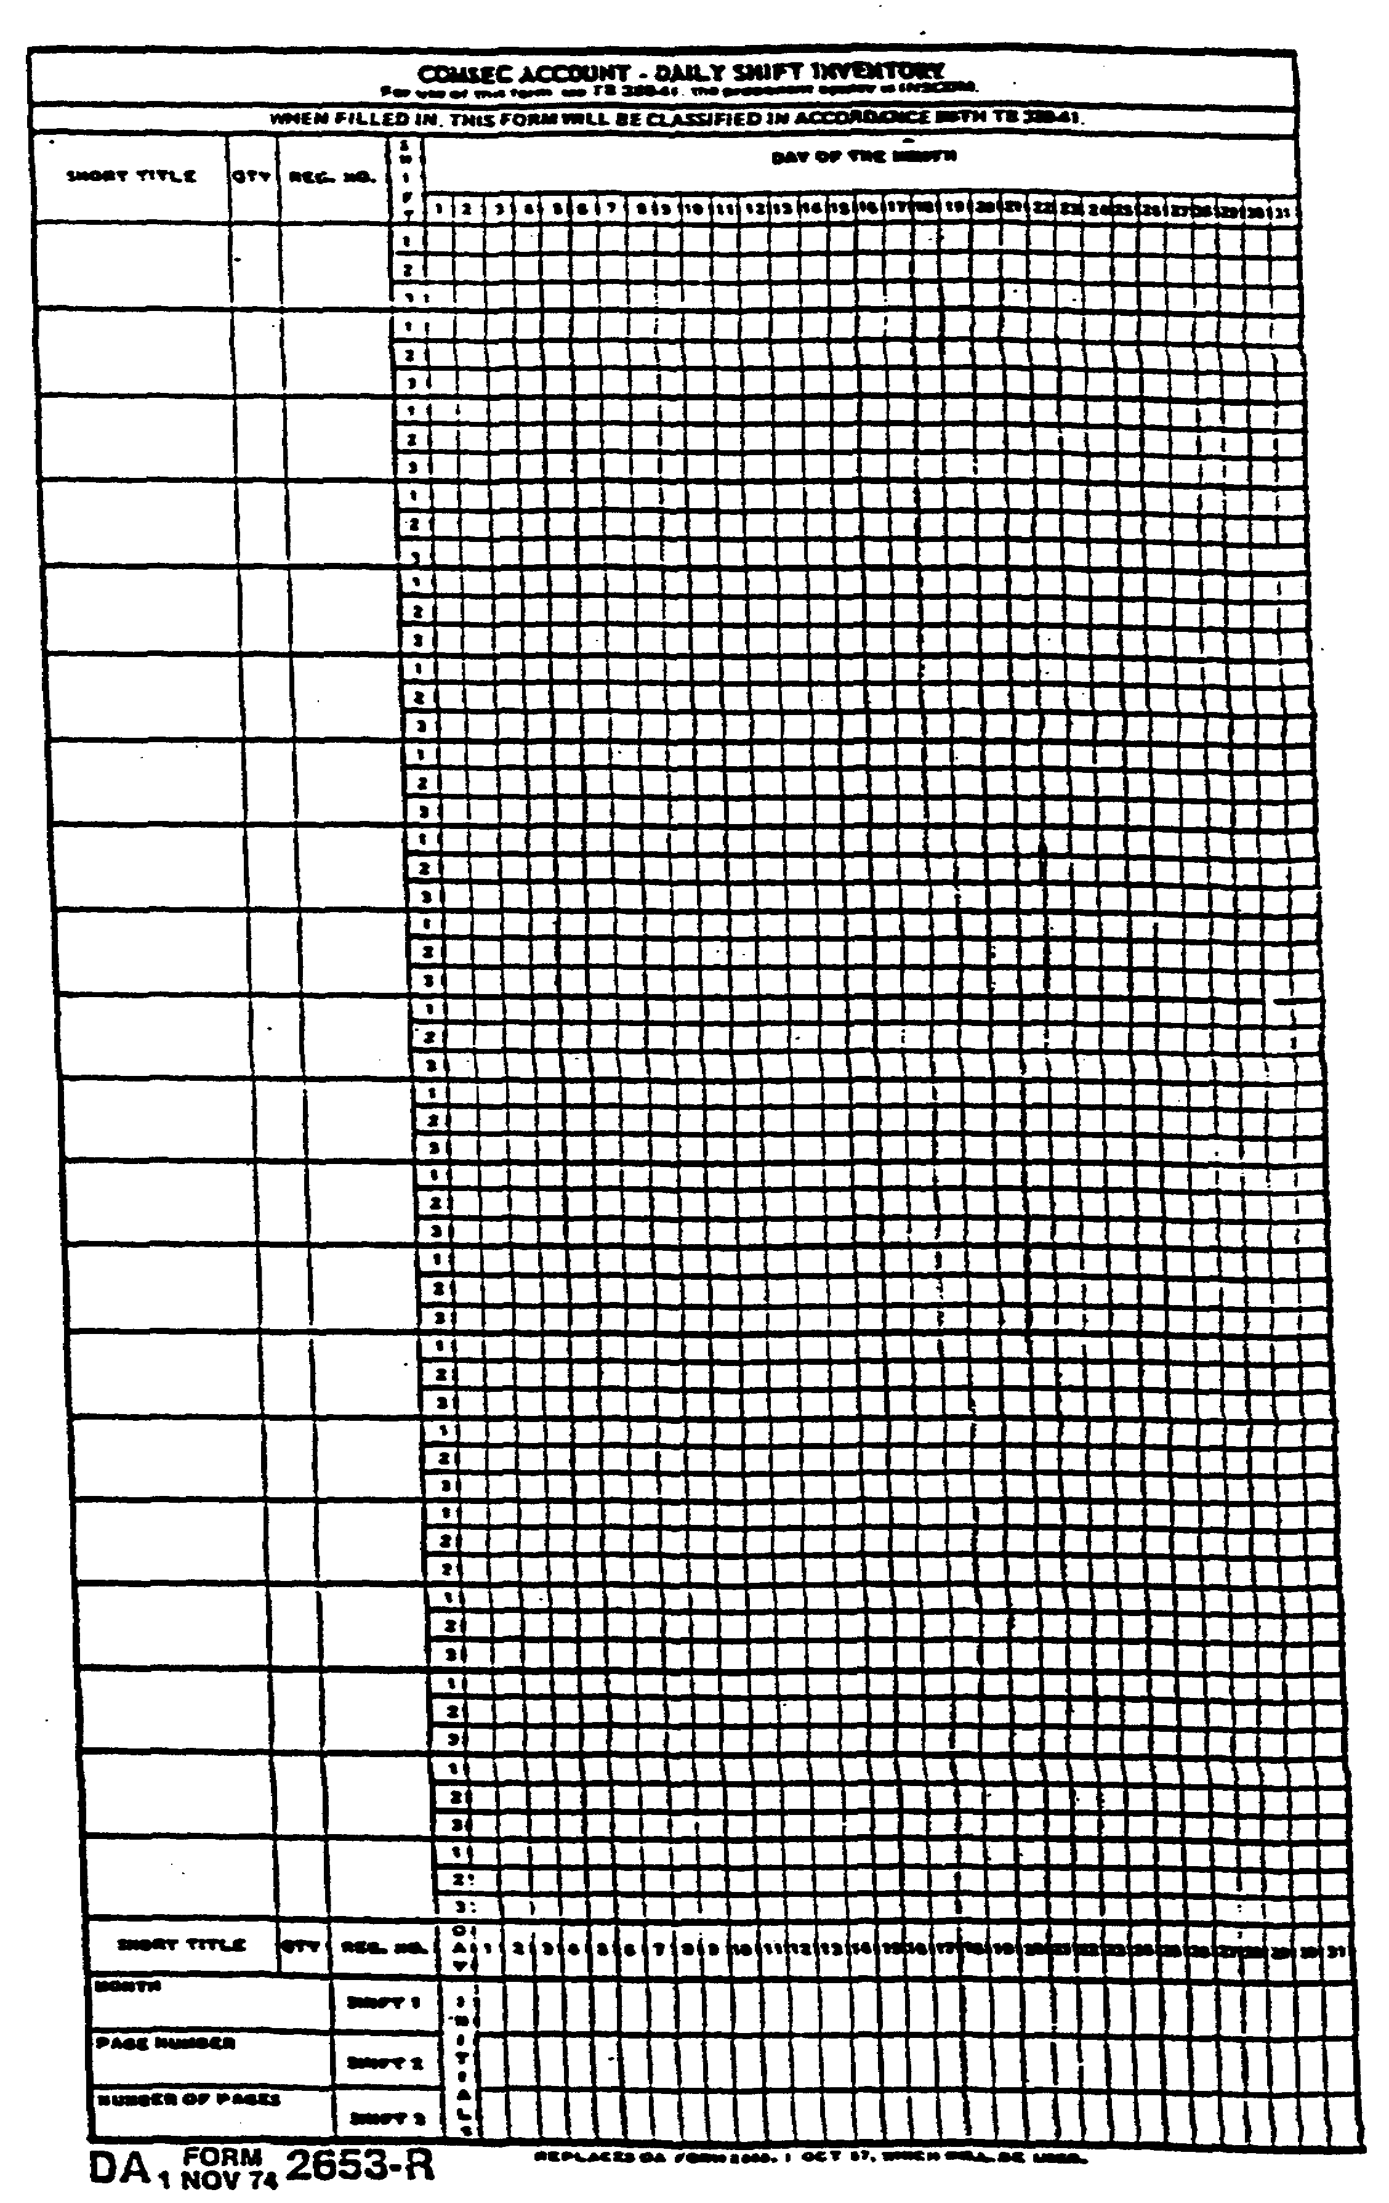

Figure 1-1. COMSEC ACCOUNT-DAILY SHIFT INVENTORY.

IT 0307 1-2

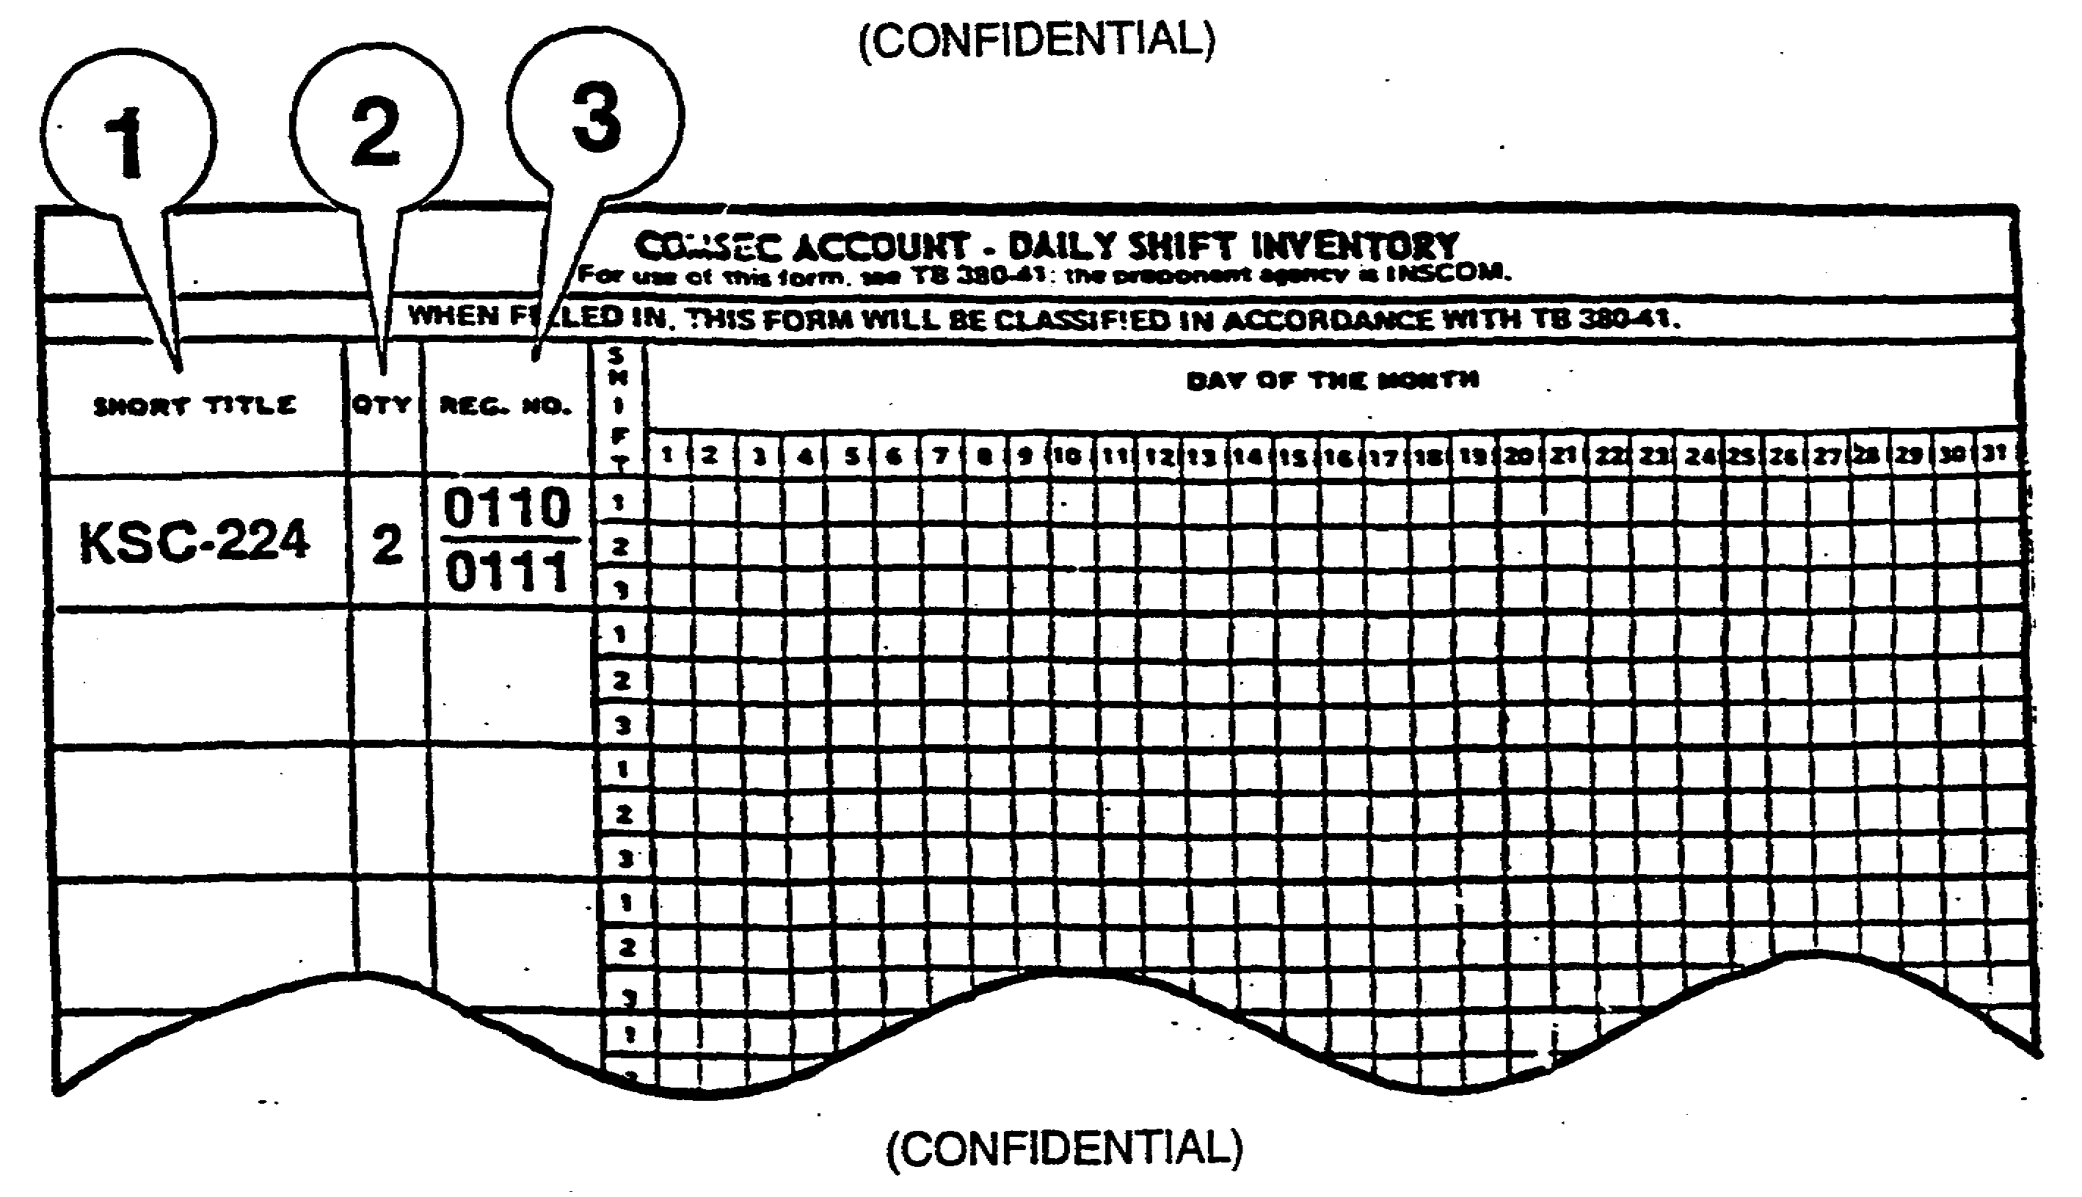

Figure 1-2. COMSEC ACCOUNT-DAILY SHIFT INVENTORY.

COMSEC Account-Daily Shift Inventory

1. Using a typewriter or an ink pen, enter the Short Title of each individual COMSEC material in the block entitled SHORT TITLE at the top left-hand side of the form (e.g. KSC-224) Figure 1-2.

NOTE: A complete or substantially complete (i.e. 75% or more) listing of a specific organization's holdings of Keying Material is classified CONFIDENTIAL and the DA Form 2653-R must be marked appropriately.

2. In the block entitled QTY, enter the quantity of the COMSEC material(s) entered in SHORT TITLE above (e.g. #2).

3. In the block entitled REG. NO., enter the Register Number of each individual COMSEC item accounted for in QTY above (e.g. 0110, 0111).

a. Normally COMSEC materials issued to a unit are numbered consecutively (e.g. 0110, 0111). When three or more COMSEC materials are numbered consecutively, list the first and last numbers only under REG. NO. (e.g. 0181-0183). Materials with nonconsecutive REG. NO's. (e.g. 0150, 0156) are listed as separate entries.

b. Most cryptographic equipment (i.e. KW-7, KWK-7, etc.) is not accountable by serial number. When listed on DA Form 2653-R, the Reg. No. block will be left blank. However, if

1-3 IT 0307

You will be informed if your COMSEC equipment is accountable by serial number. Now move to the bottom of the form to fill in the following information as shown in Figure 1-3.

4. Enter the MONTH in the appropriate block (e.g. September).

5. Enter the PAGE NUMBER in the appropriate block (e.g. 1 or 2, 3, etc.).

6. Enter the total NUMBER OF PAGES used for the inventory in the appropriate block (e.g. 1 or 2, 3, etc.)

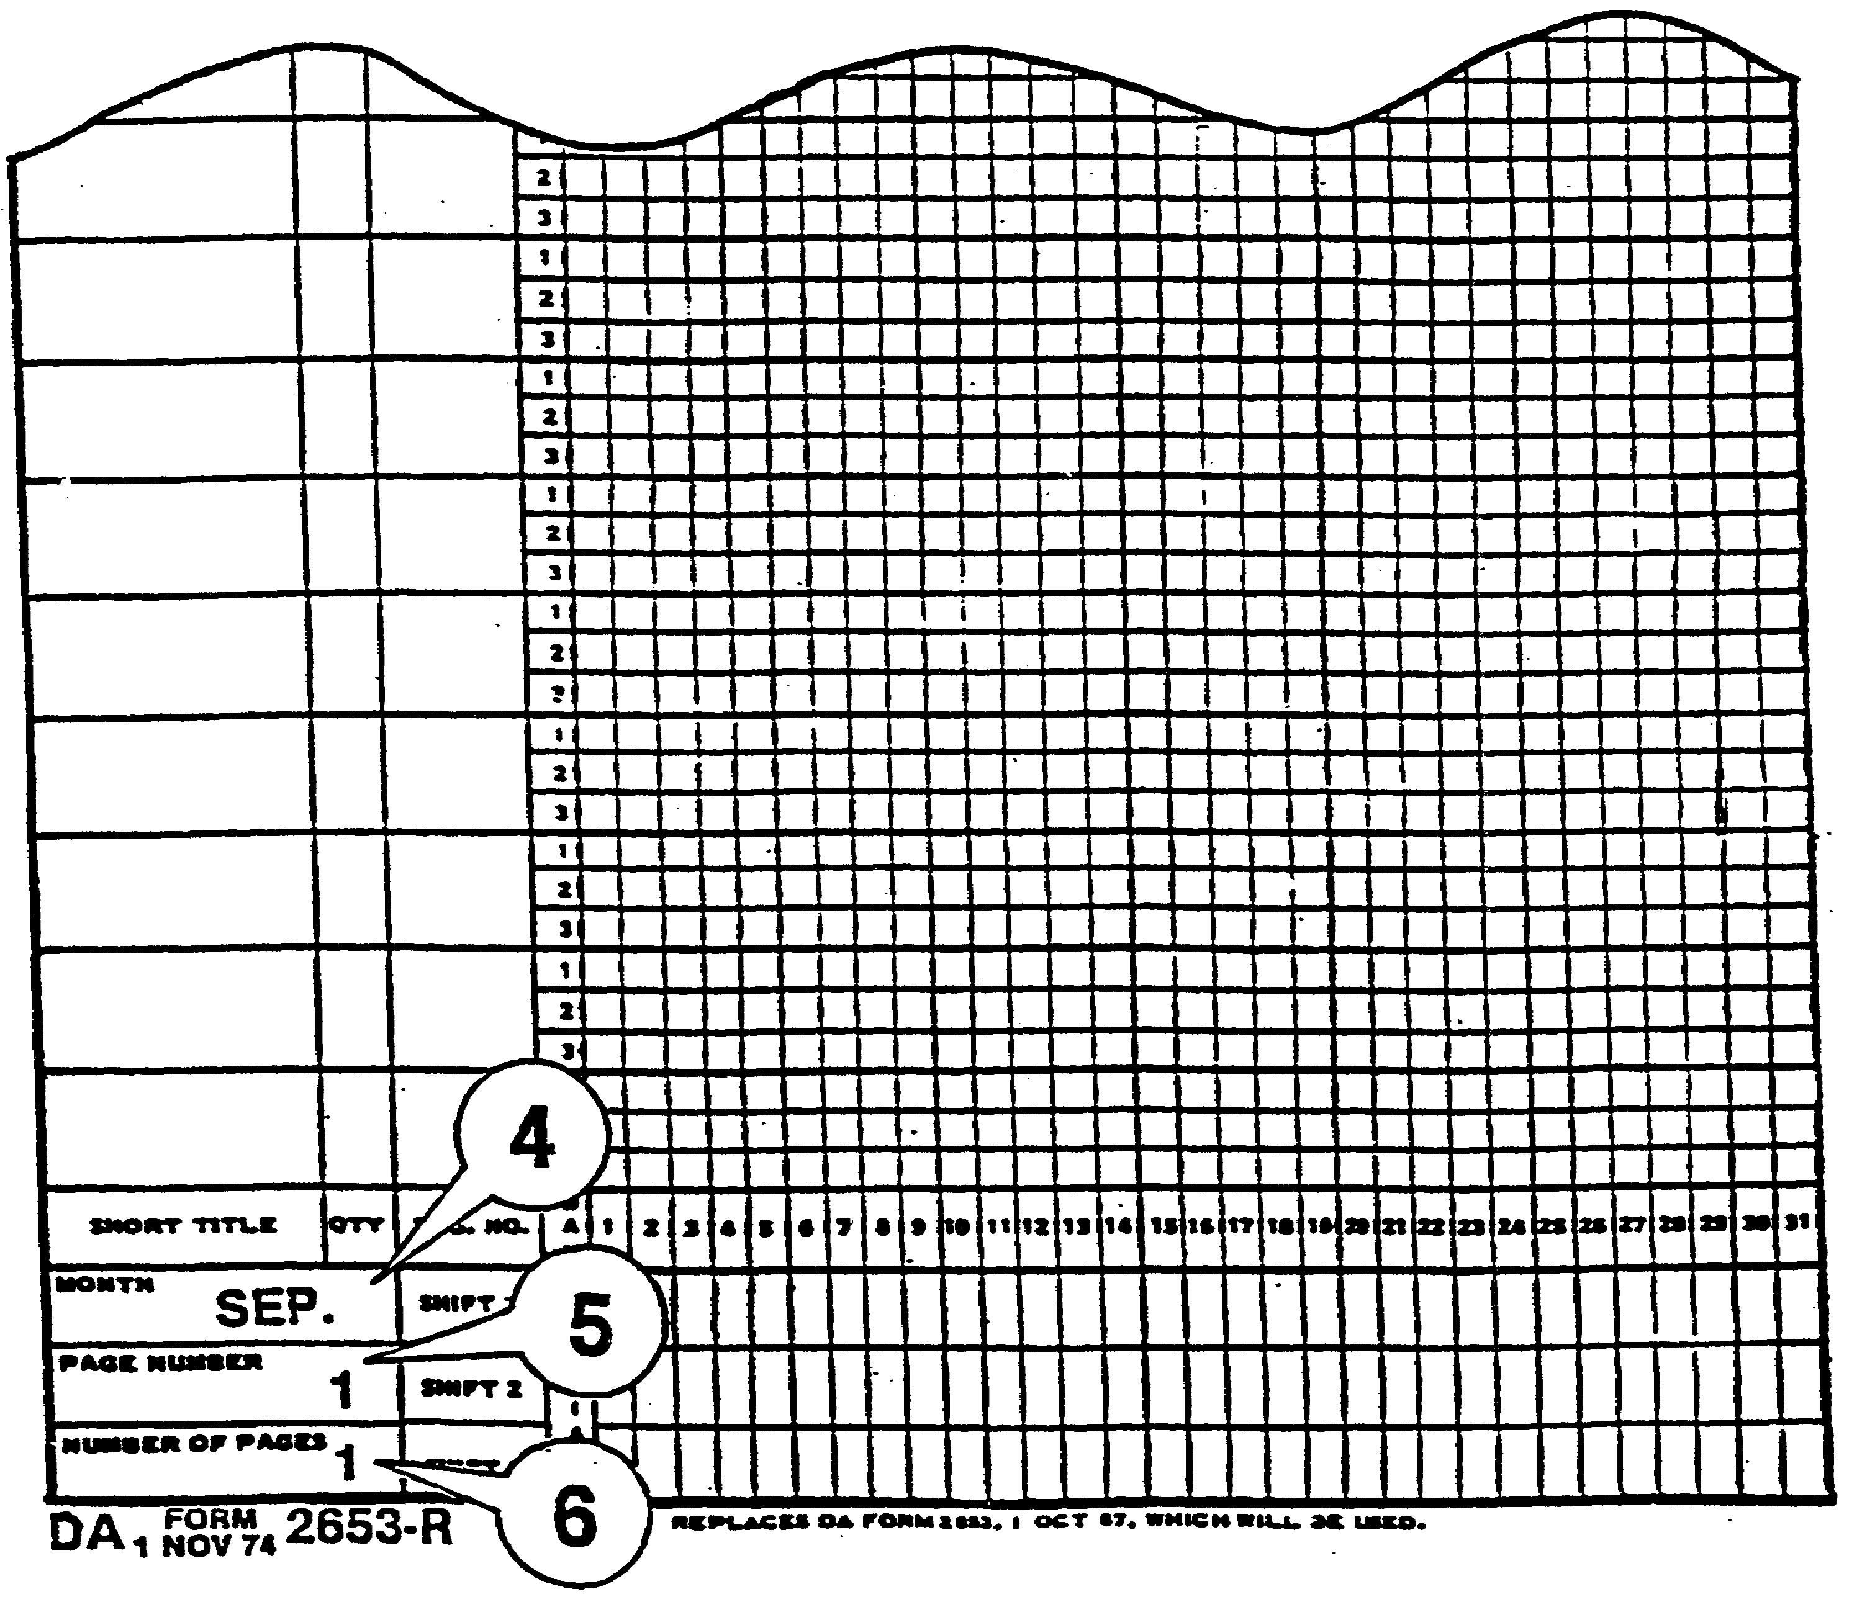

Figure 1-3. DA Form 2653-R Blocks 4, 5, and 6.
LESSON

IT 0307 1-4

PRACTICE EXERCISE

Enter the following information concerning COMSEC materials in the appropriate blocks on DA Form 2653-R Figure 1-4:

SHORT TITLE QTY REG. NO.

KSP-15 2 0115, 0116
KSL-10 1 0120
KTP-35 2 0150, 0151

1-5 IT 0307

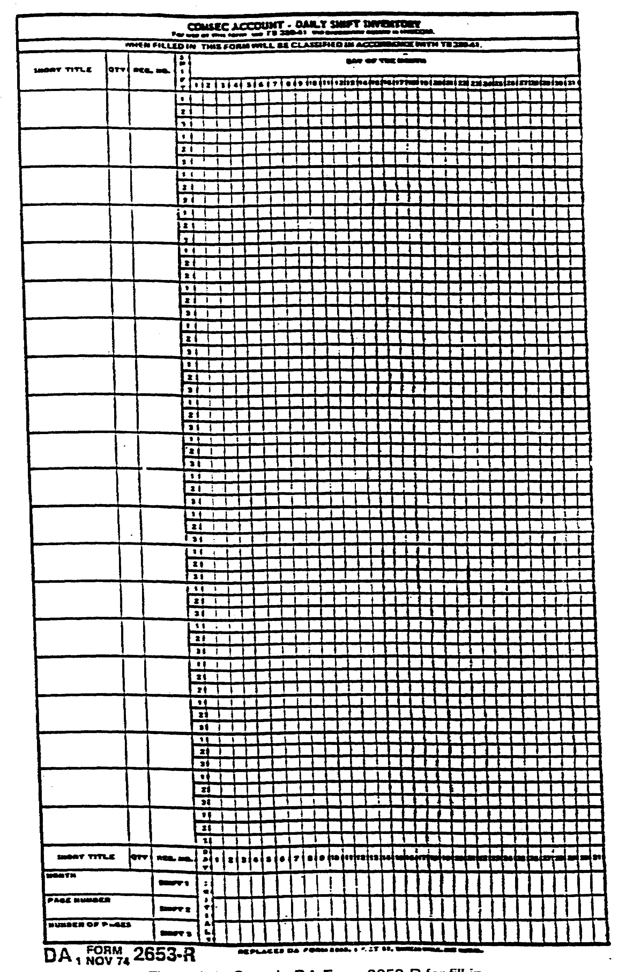

Figure 1-4. Sample DA Form 2653-R for fill-in.
LESSON

IT 0307 1-6

PRACTICE EXERCISE #1

ANSWER KEY AND FEEDBACK

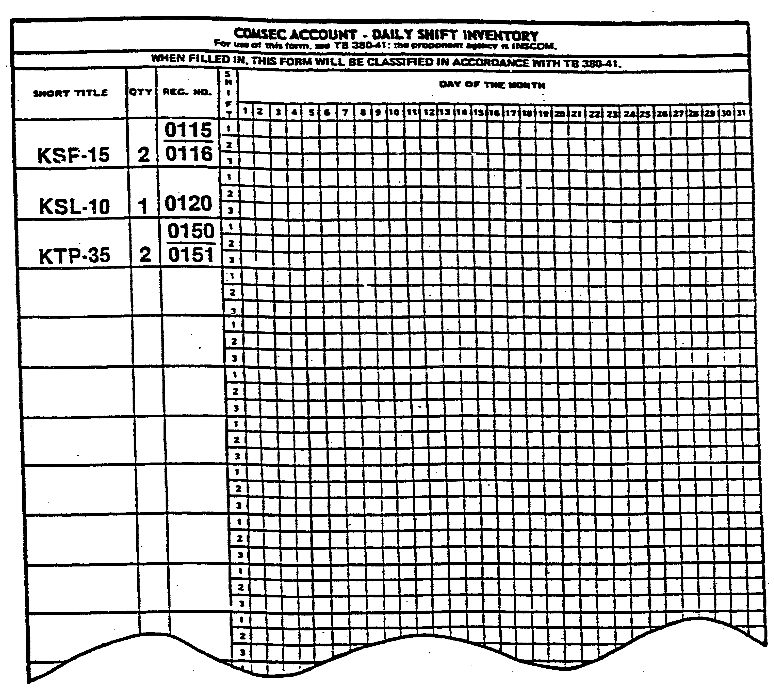

Figure 1-5. DA Form 2653-R Completed

1-7 IT 0307

The next part of this lesson will teach you to inventory COMSEC material.

Inventory COMSEC Material

1. Locate the block entitled SHIFT figure 1-6 (next to REG. NO. at the top lefthand side of the form). Notice that there are three small blocks labeled 1, 2 and 3 directly below the block entitled SHIFT. These numbers represent the three shifts of a 24-hour day. For this lesson, SHIFT 1 will be used.

2. Locate DAY OF THE MONTH at the center top of the form. Below this heading you will find the numbers 1 through 31 representing the number of days in any given month.

3. Place a check (✓) in the correct SHIFT area for the correct DAY OF THE MONTH for each COMSEC item inventoried (e.g. 20 SEP).

NOTE: The correct DAY OF THE MONTH is the day the inventory is taken.

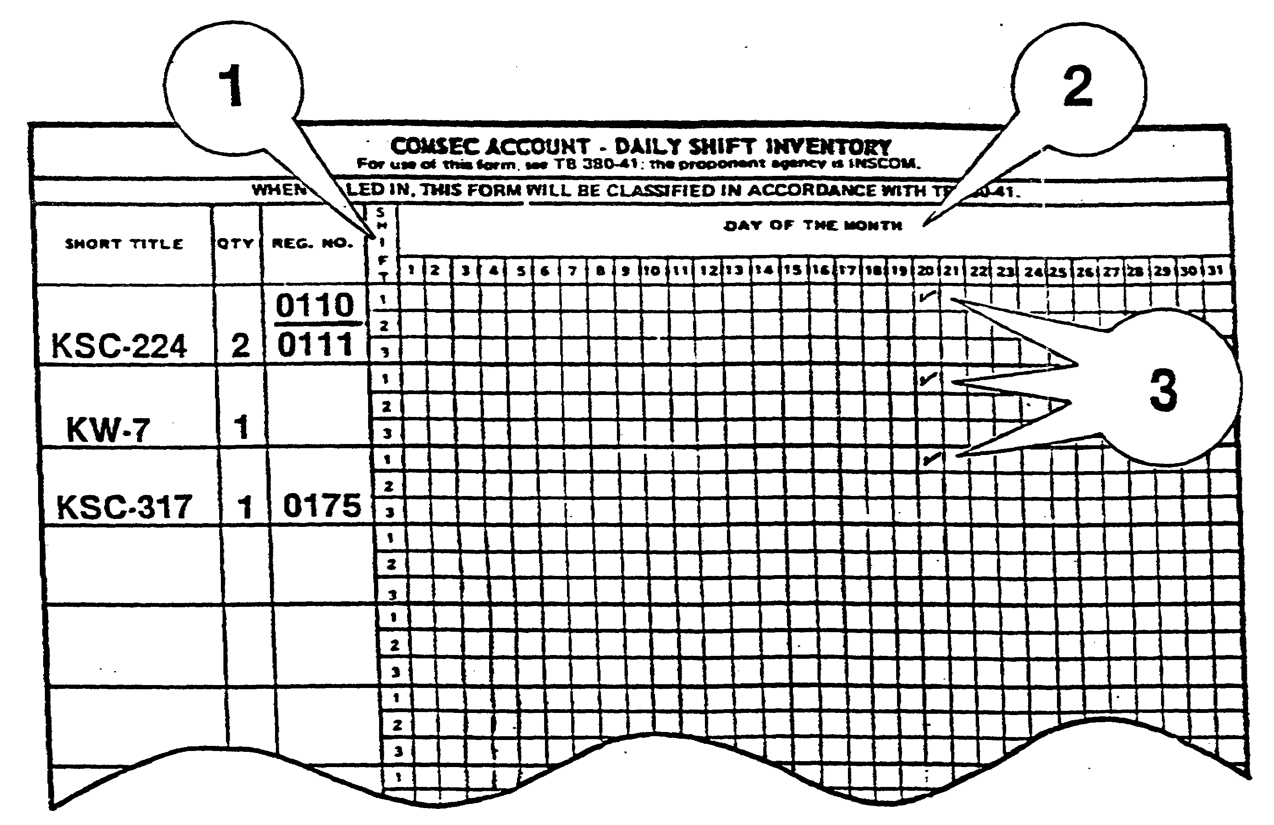

Figure 1-6. DA Form 2653-R Blocks 1, 2 and 3.

IT 0307 1-8

4. Locate the blocks entitled SHIFT 1, SHIFT 2 and SHIFT 3 at the bottom of the form in figure 1-7.

5. Enter your initials in the correct SHIFT area for the correct DAY OF THE MONTH. Be sure to initial the correct SHIFT block.

6. Remember, SHIFT 1 and the date of 20 SEP will be used for this lesson.

IMPORTANT!! If material is discovered missing after completing COMSEC Account Daily Shift Inventory (DA Form 2653-R), the site supervisor should be notified IMMEDIATELY!!

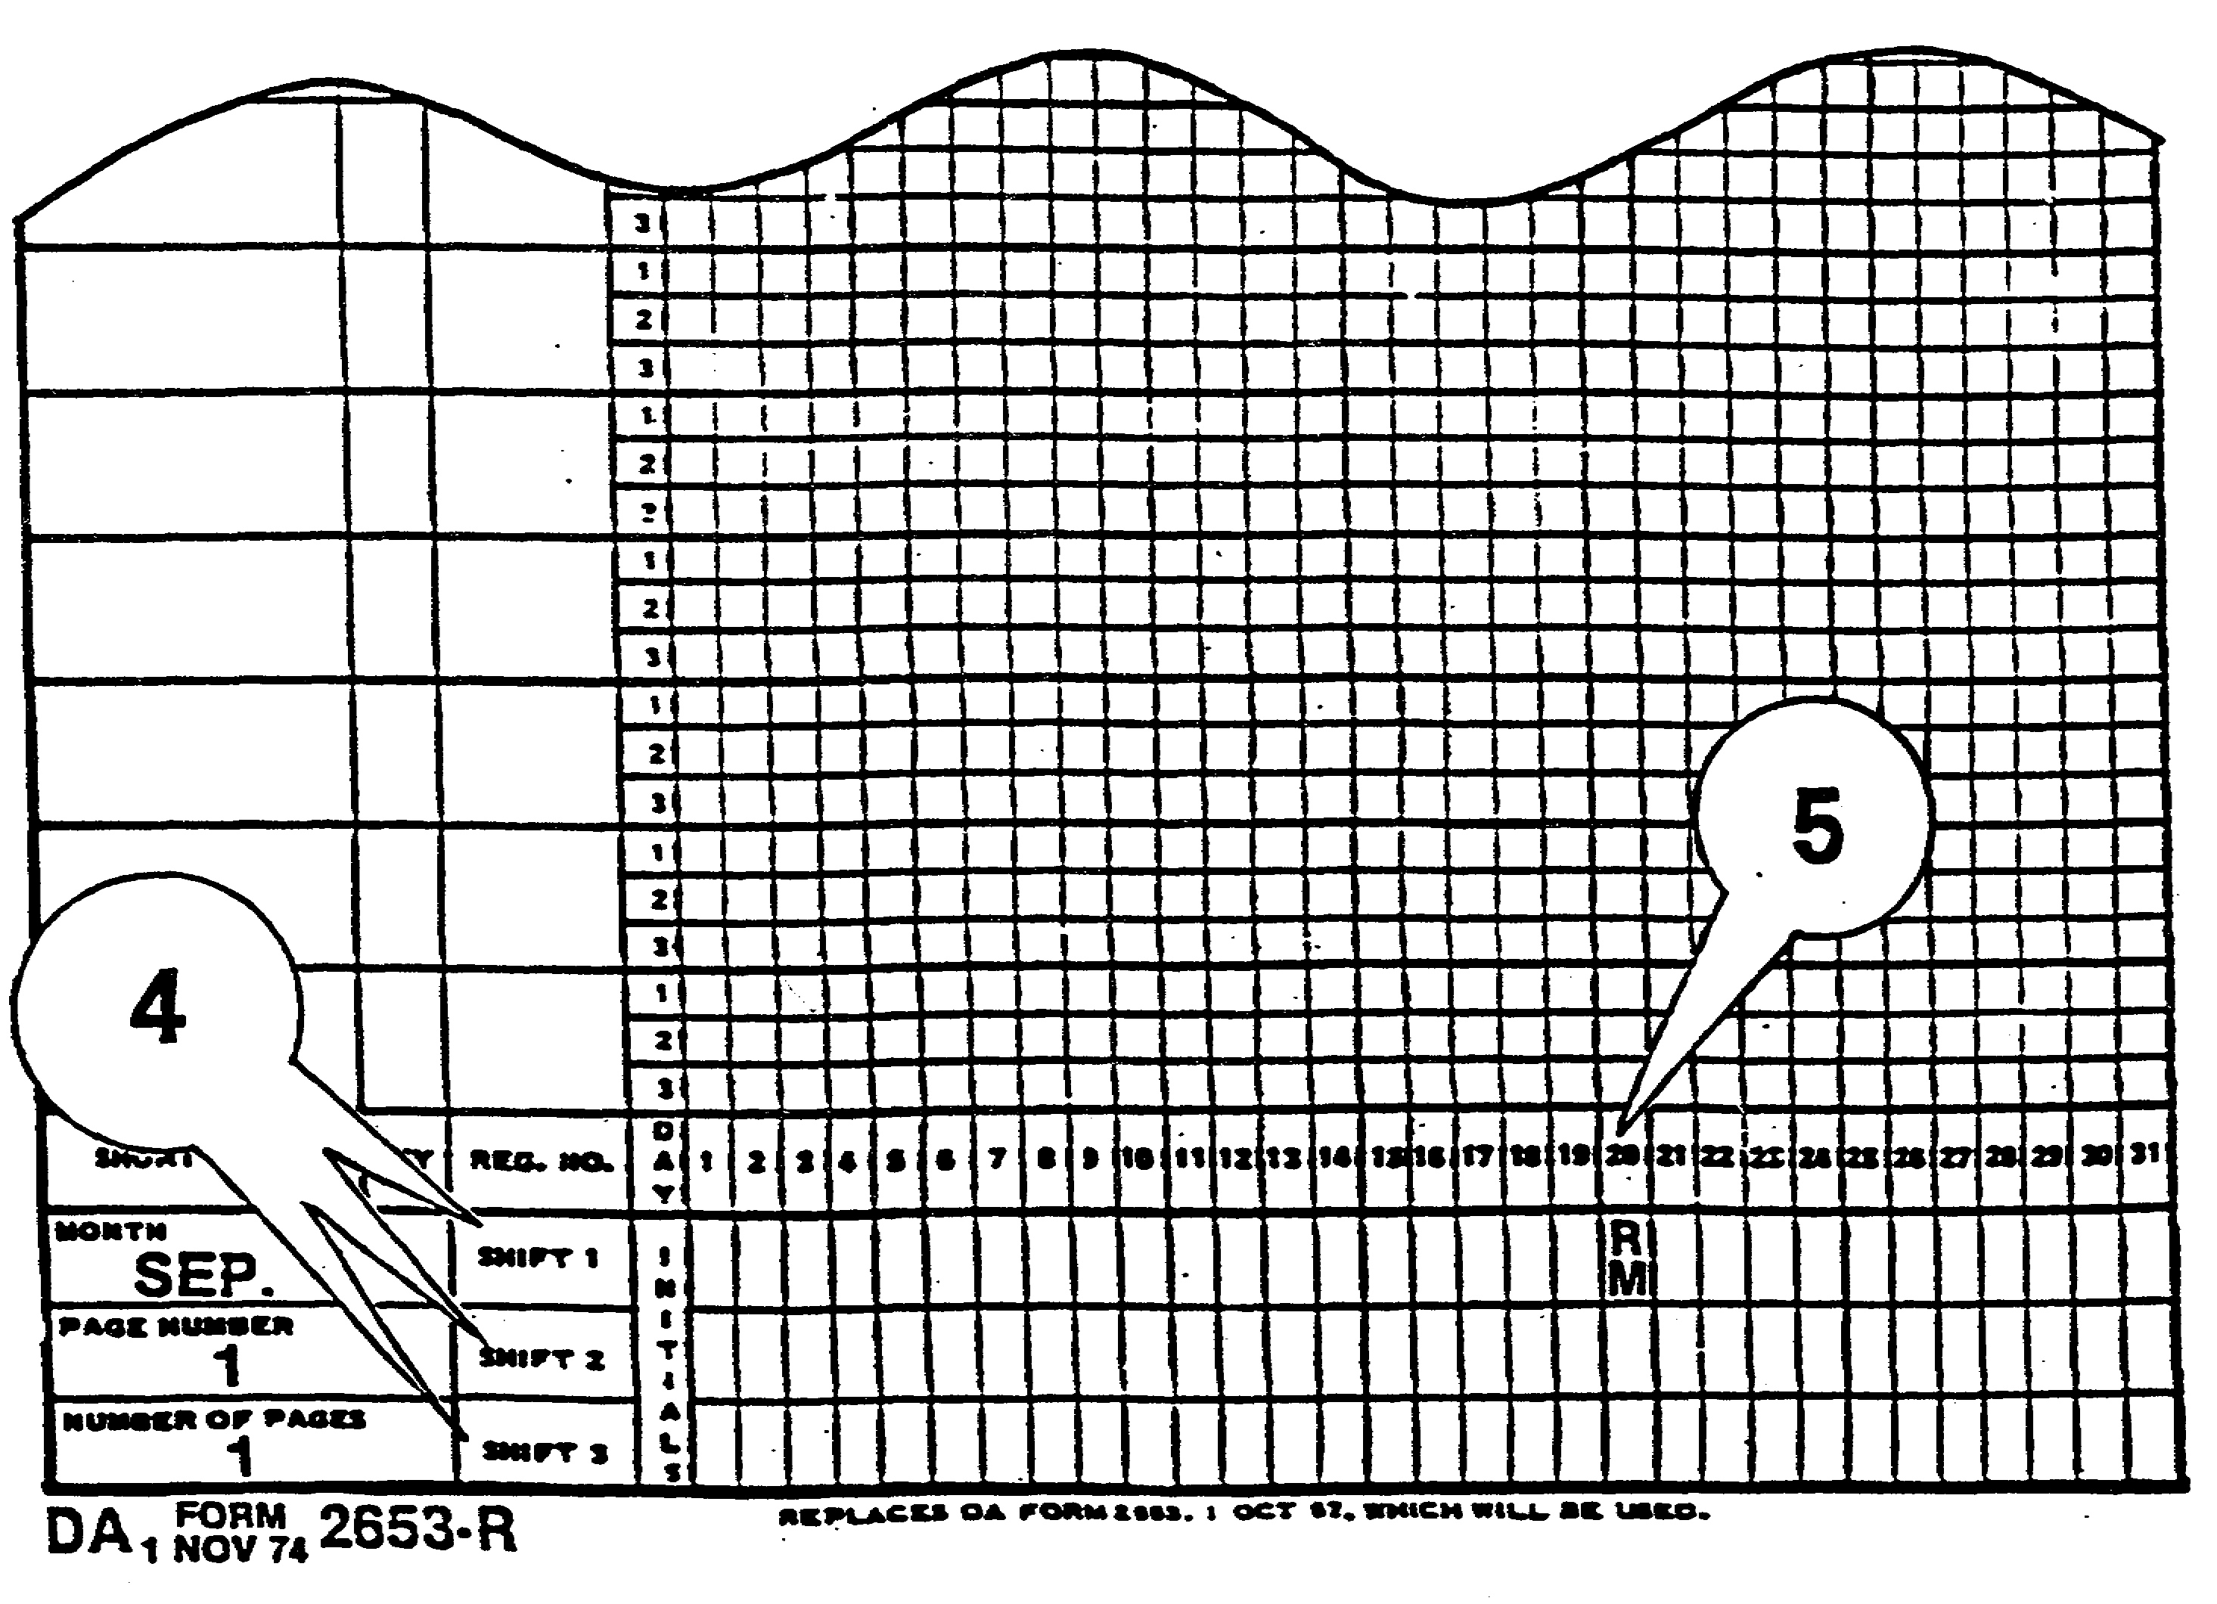

Figure 1-7. DA Form 2653-R Blocks 4 and 5.

1-9 IT 0307

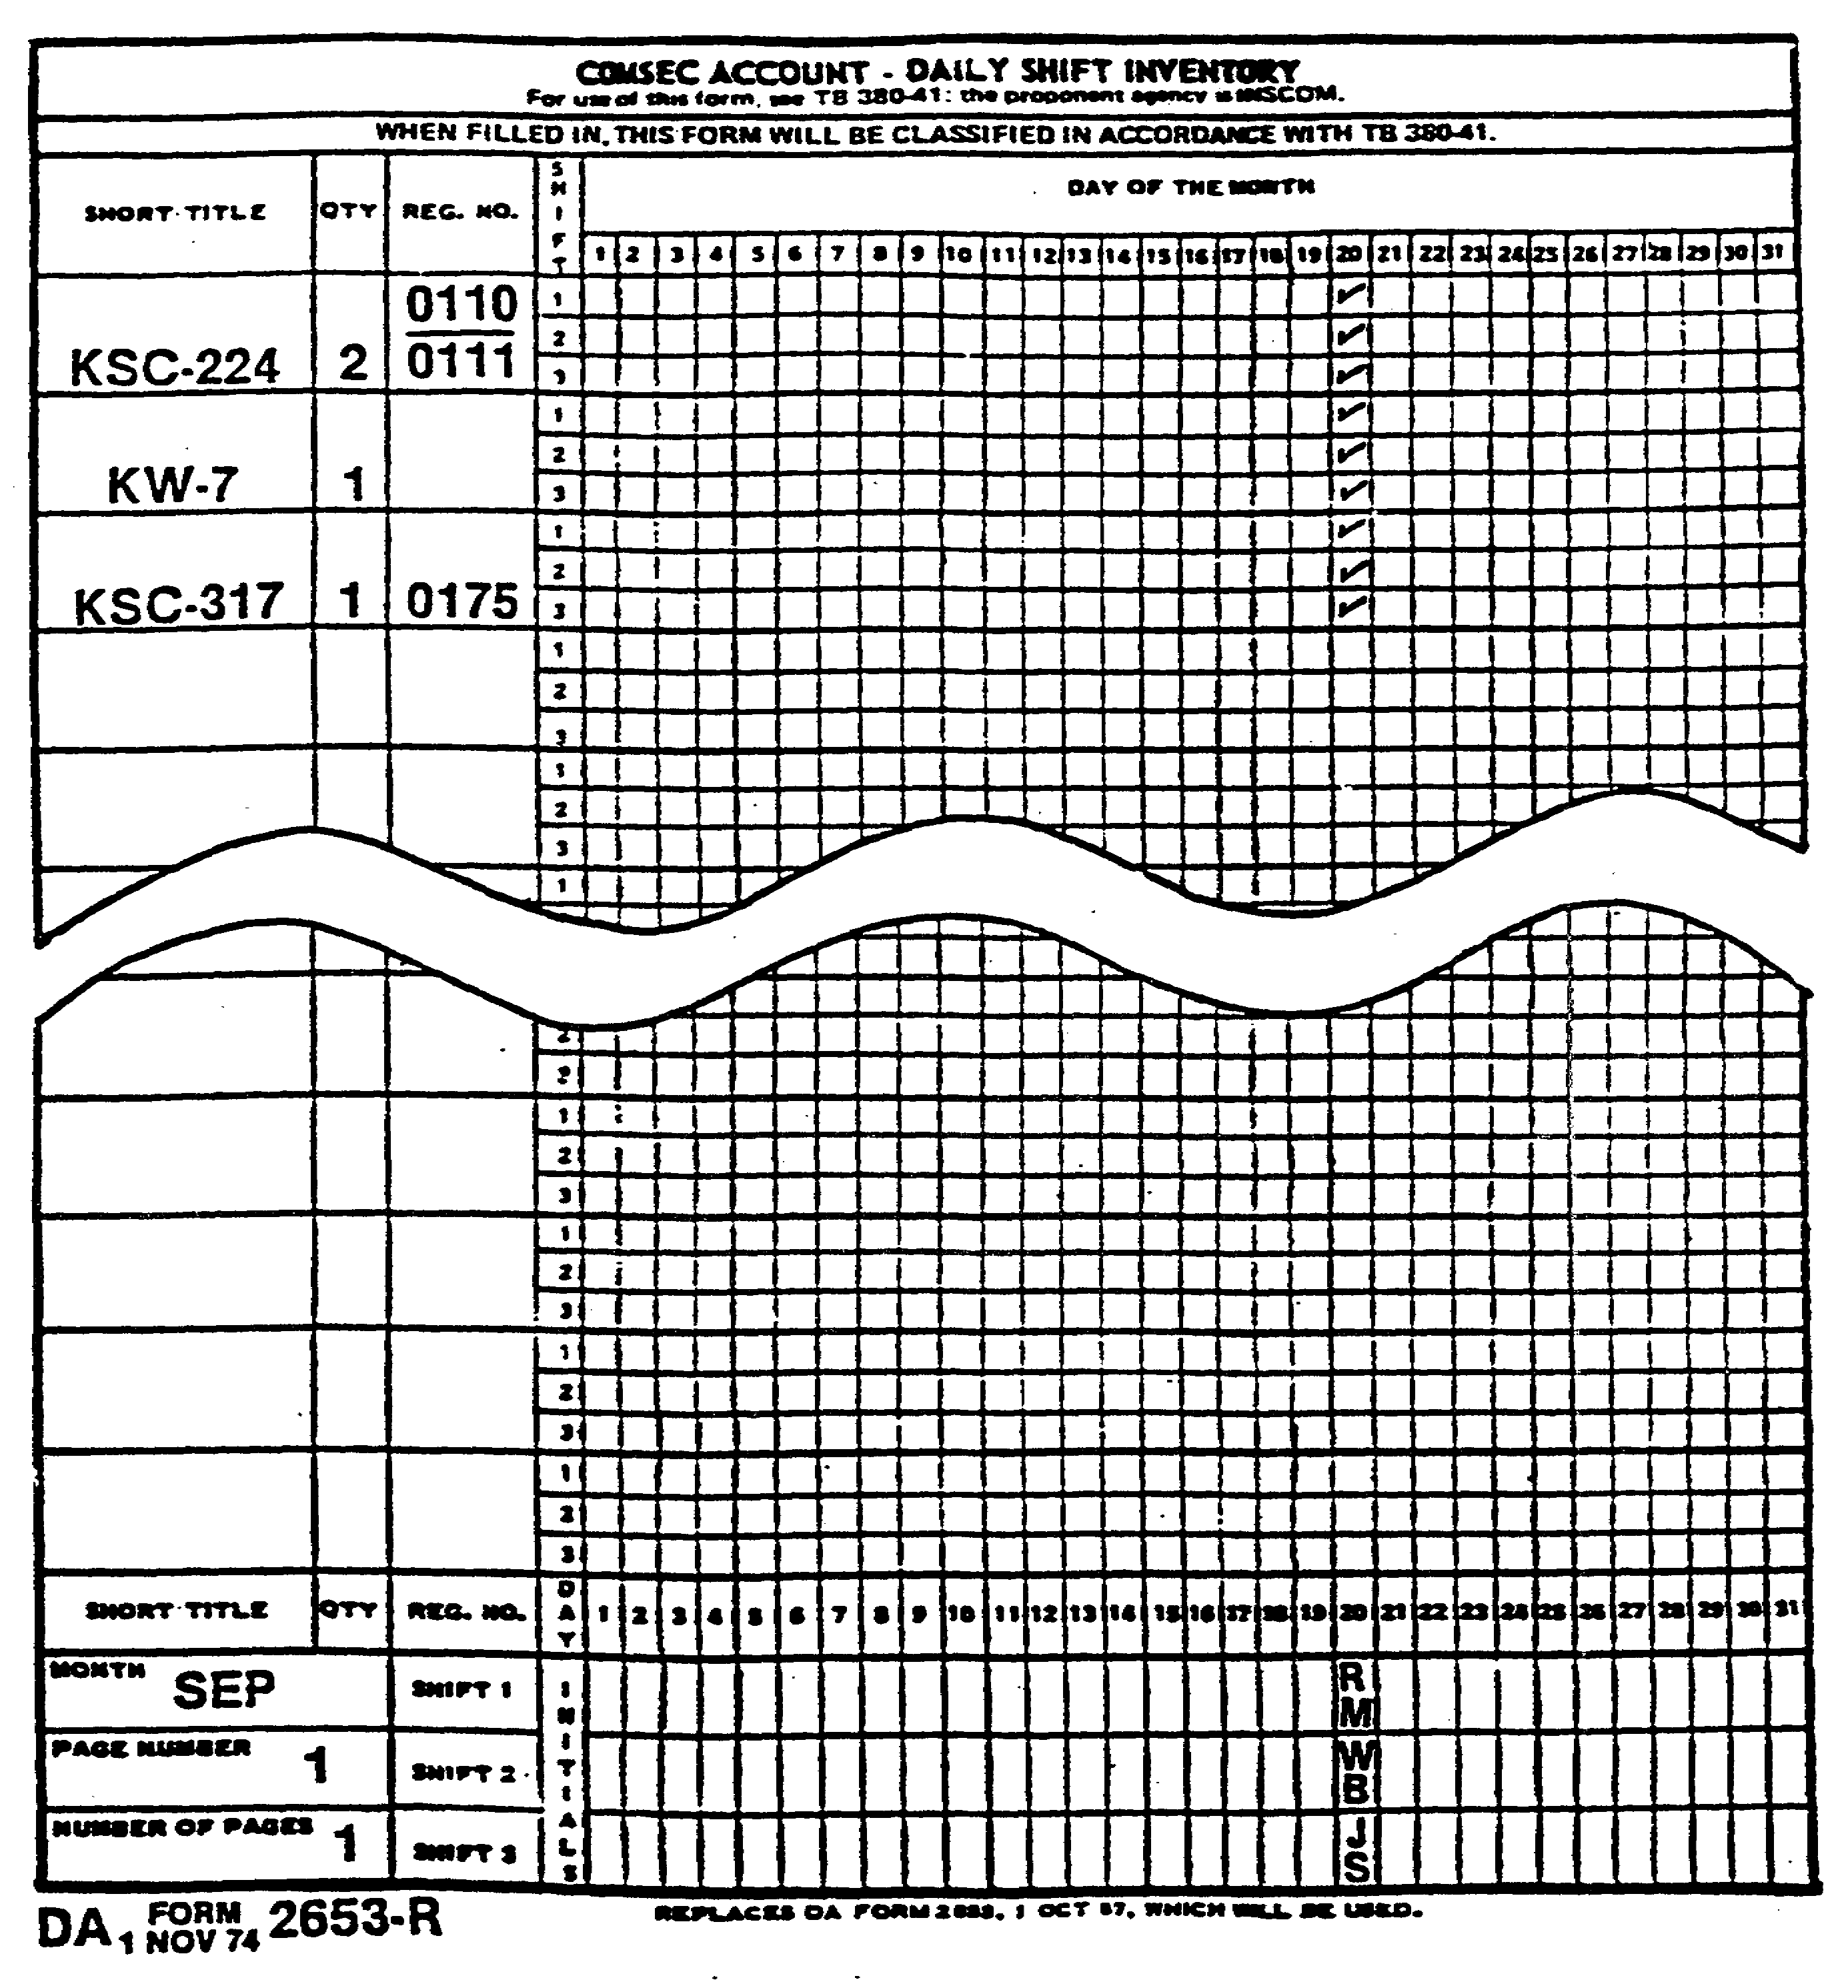

Figure 1-8. Completed QA Form 2653-R.

A completed DA Form 2653-R filled in by each of the three shifts is shown above.

IT 0307 1-10

LESSON

PRACTICE EXERCISE #2

Using the DA Form 2653-R figure 1-9, enter the MONTH, PAGE NUMBER and NUMBER OF PAGES in the appropriate blocks of the form. Use the month of October for this exercise.

Place a check (T) in the correct SHIFT area for the correct DAY OF THE MONTH for the items previously listed on the form. Use SHIFT 1 and the date of 15 Oct.

Enter your initials in the correct SHIFT area for the correct DAY OF THE MONTH.

Turn the page to check your responses.

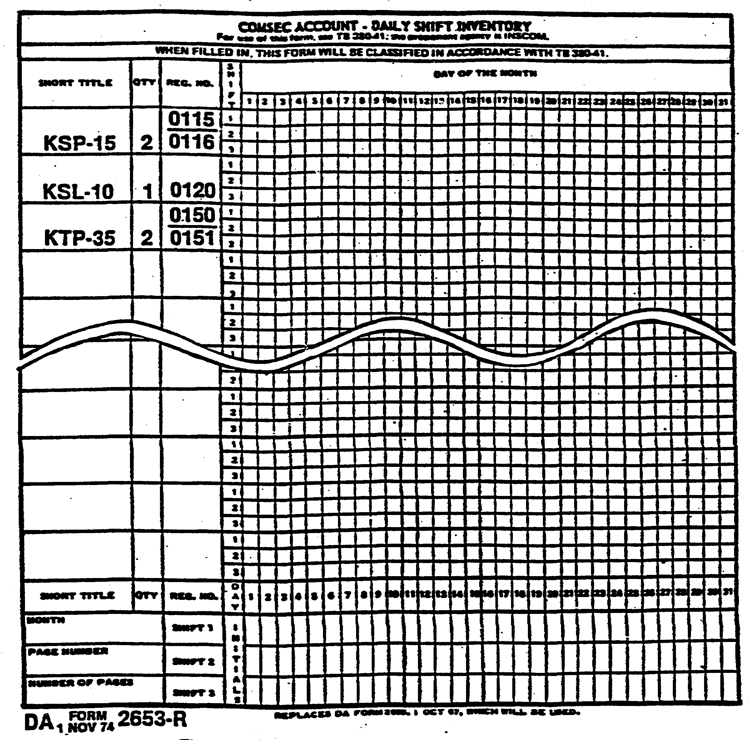

Figure 1-9 DA Form 2653-R COMSEC Account-
Daily Shift Inventory

1-11 IT 0307

LESSON

PRACTICE EXERCISE #2

ANSWER KEY AND FEEDBACK

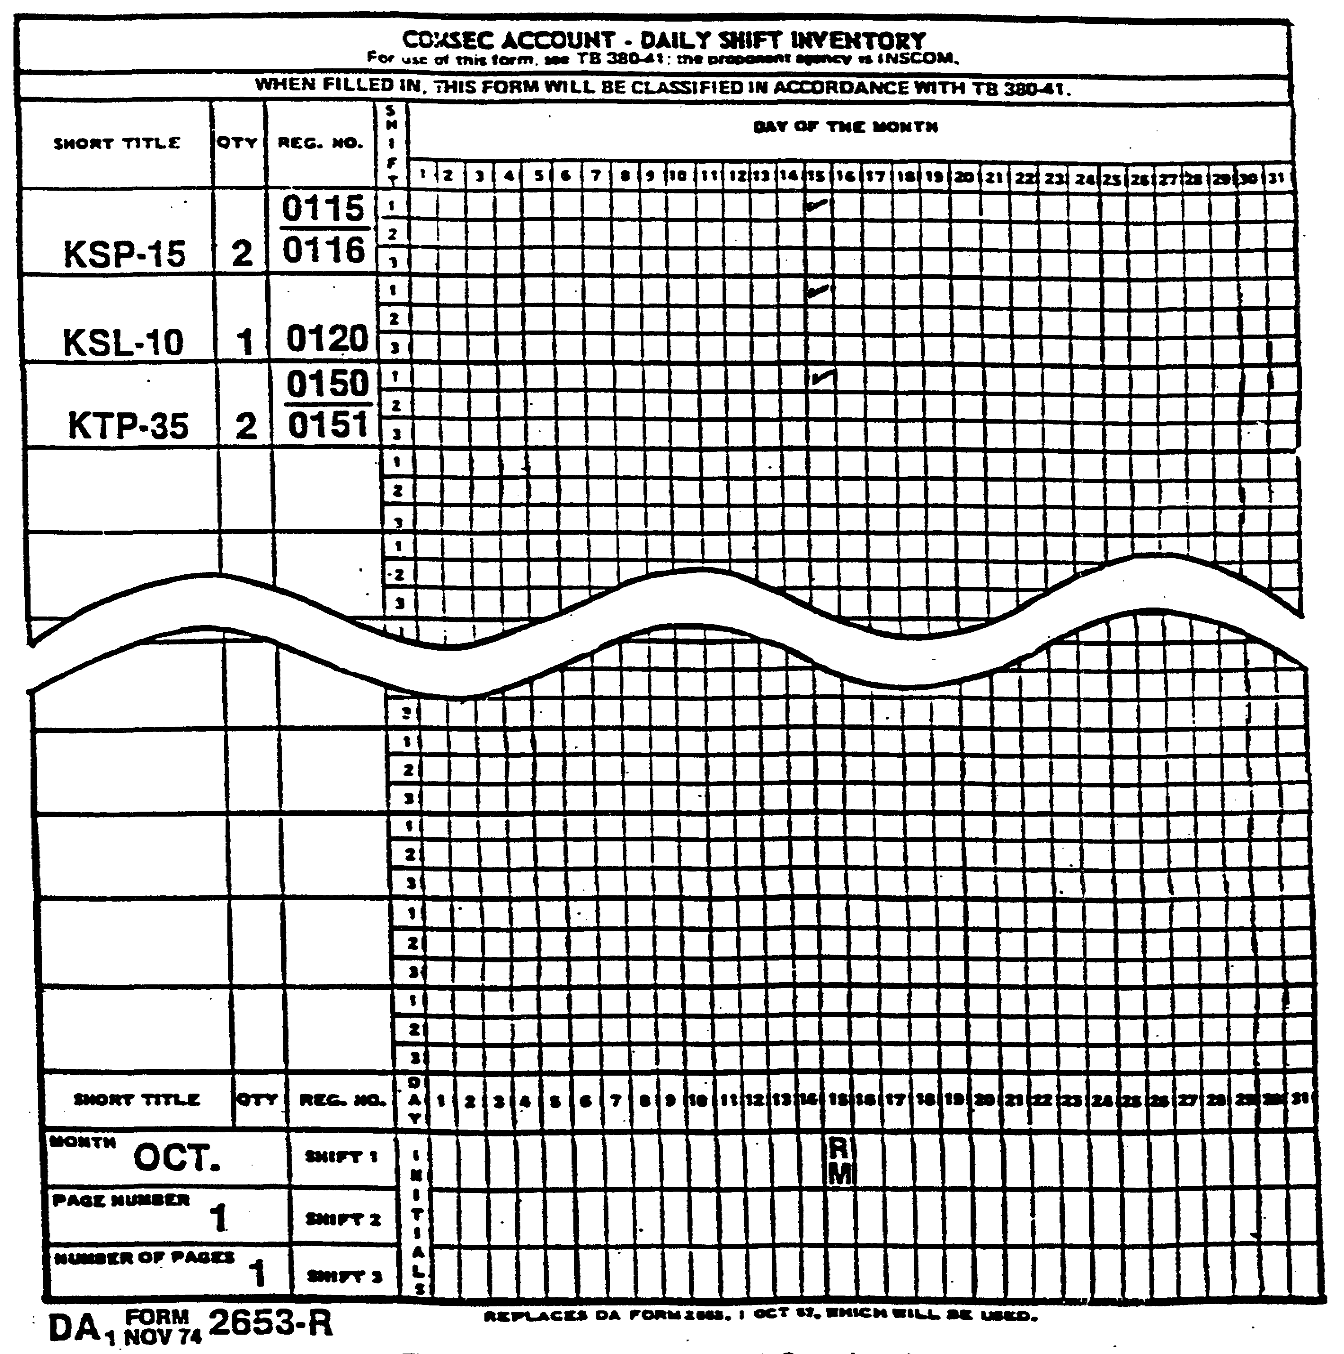

Figure 1-10. DA Form 2653-R Completed

IT 0307 1-12

